Smowl Tech

By this handbook we will guide you through the installation, configuration, use of SMOWL’s facial recognition software and lastly visualization of its results in Moodle version 2.4.

1. Installing requirements.
2. Installing the plugin.
3. Configuring SMOWL in a course.
4. Configuring SMOWL in a quiz.
5. Display results.
6. Installing requirements

Firstly, we must install the necessary requirements for the proper functioning of the plugin. In case of not having the *PEAR* repository and *SOAP* library installed follow the next steps. If you already have installed them, go to section 1 (*Installing the plugin*).

The following steps consider that you have already installed a web server (*Apache*) and *PHP.*

WINDOWS

1. Find where *PHP* is installed (for instance C:/php or C:/xampp/php).
2. Execute the batch file *“go-pear.bat”* by double clicking on it.
3. The previous step will generate a file called *“PEAR_ENV.reg”*. Run this file by double clicking on it.
4. If necessary, refresh *PEAR* repository.
5. Download *“go-pear.phar”* file from the following:

http://pear.php.net/go-pear.phar

1. Execute the downloaded file on the console with the following command:

php go-pear.phar

1. After performing the previous steps we will have successfully installed *PEAR* repository. In order to install *SOAP* library, execute on the console the following command:

pear install SOAP

LINUX

Execute the following commands depending on the *LINUX* version.

1. *Debian/Ubuntu*:

sudo apt-get install php-soap

pear install SOAP

1. *Redhat/CentOS/Fedora*:

yum install php-soap

yum install php-common

pear install SOAP

1. Installing the plugin

In this section we will explain you the steps you must follow to install SMOWL’s face recognition software in Moodle.

1. The first step to install the plugin is to **modify a file** in ***"smowlinformes"* folder**. The file we must modify is ***"configsmowl.php"***. In this file, we need to change the path which is in the line that starts with *"$ CSM-> SOAPorig ..."*. This path points to a file called *"Client.php"* which is part of the SOAP library that we installed in the previous section. Therefore, what we must do is to **locate** ***"Client.php"*** file in the folder of our computer where *SOAP* had been installed, and **write the path** **in** ***"configsmowl.php"*** file.

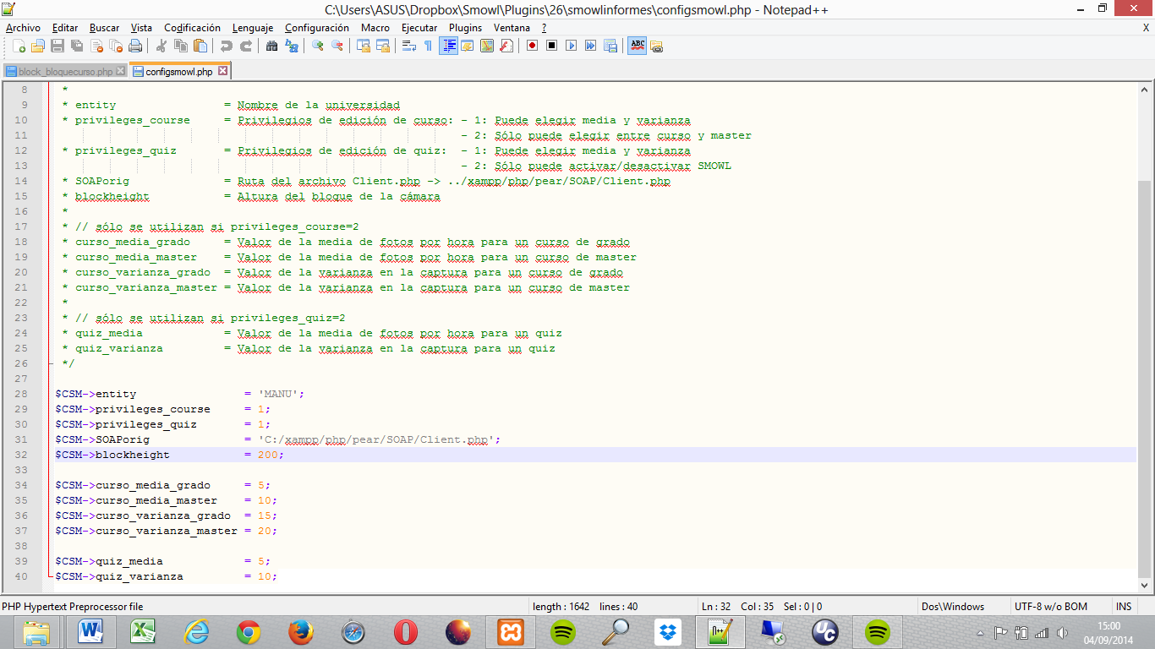

1. The next step to install SMOWL’s plugin is to **copy** the **6 folders** by which it is composed into the correct **directories within Moodle’s structure**.
   1. **bloquecurso** and **bloquequiz**: We must **copy** these two folders within the **Moodle’s directory** where ***blocks* are found**. This folder is in the following location inside Moodle’s structure:

PATH: moodleRoot/blocks/

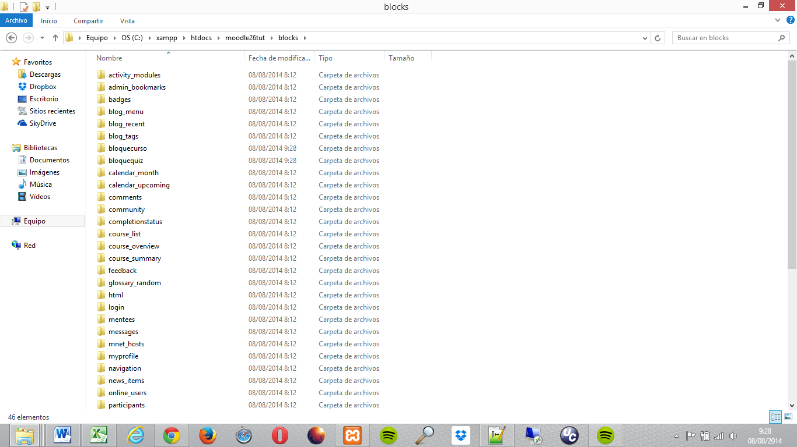In this way, the previous folder should be as follows:

* 1. **quizoptions:** We must **move** the **folder** in charge of the configuration of quizzes **to** the ***accessrule*** directory which is found in the following path inside Moodle’s structure:

PATH: moodleRoot/mod/quiz/accessrule/

This folder should look in the following way:

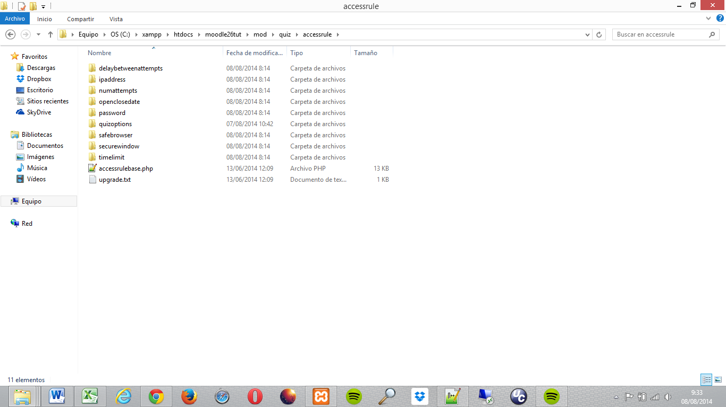

* 1. **smowl:** It should be **placed** within the ***pix*** **directory** at the root of Moodle. The mentioned directory is in the following location:

PATH: moodleRoot/pix/

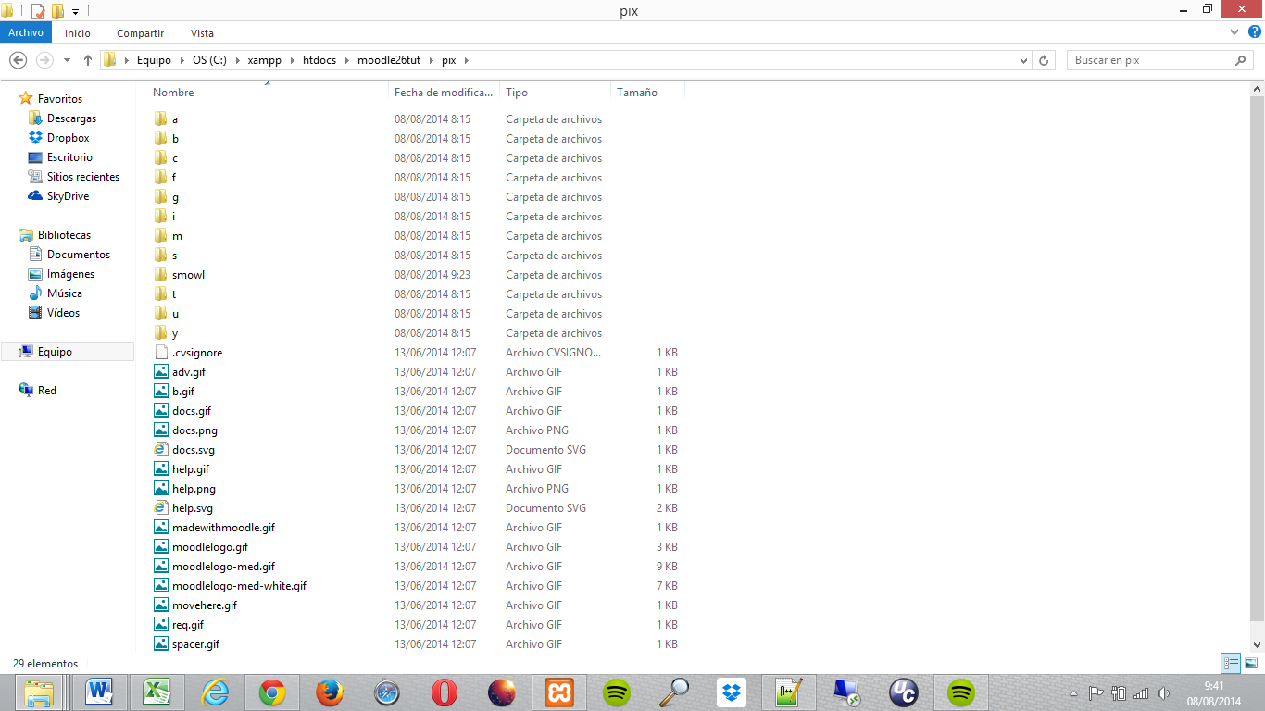Thus, it should look like the following image:

* 1. **smowlcourseoptions** and **smowlinformes:** We have to **copy** these two folders into the ***report*** **directory** within Moodle’s root folder which is in the following location:

PATH: moodleRoot/report/

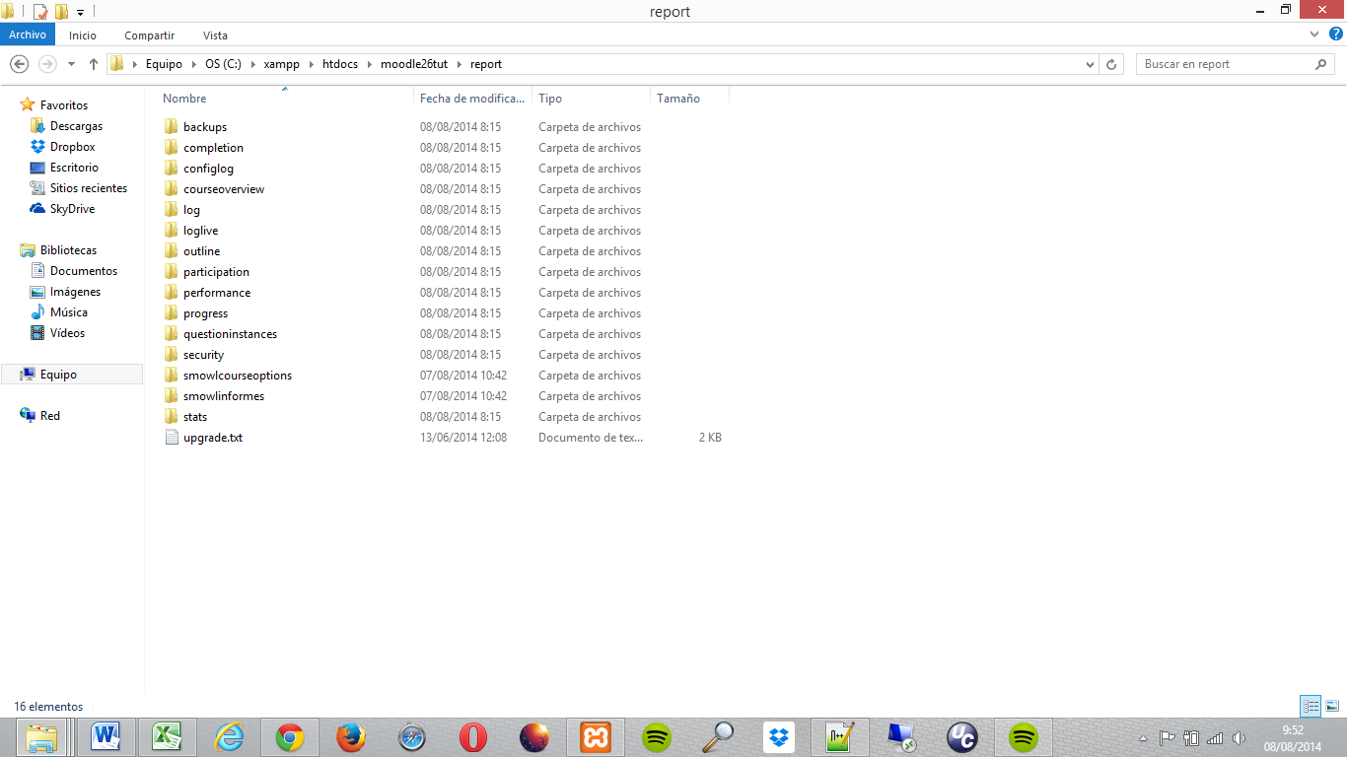These folders should stay as follows:

1. 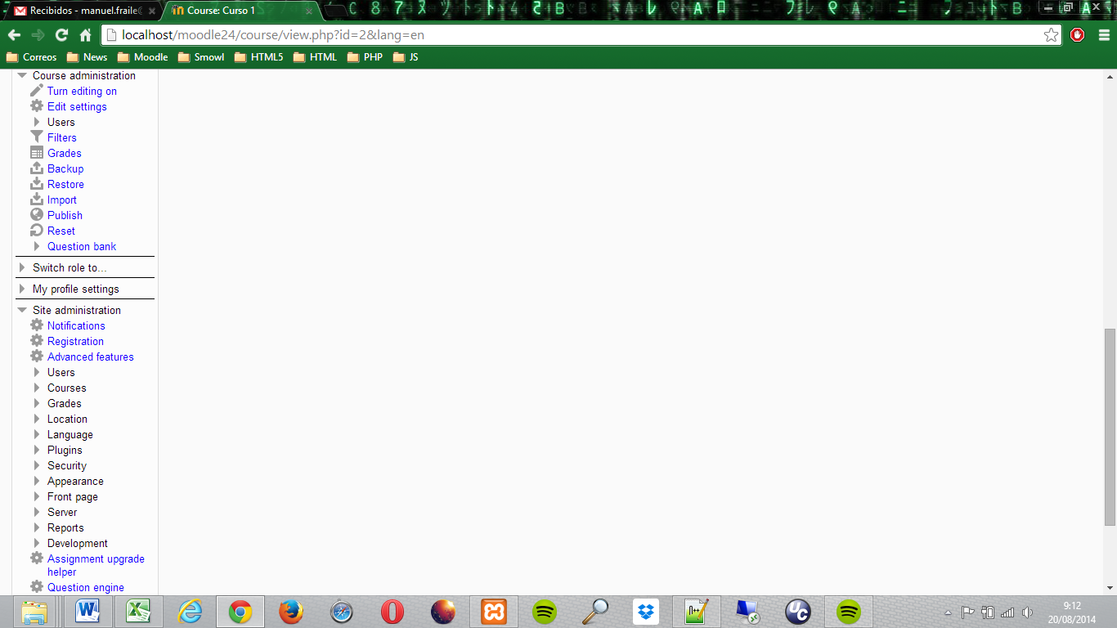Once we have placed all the folders in the correct place, we must **click** on the ***"Notifications"*** **option** which is found in the *"Site administration"* section of *"Settings"* block.
2. Then, in the next window the summary of the extensions that we will install will be shown. Here we must **press** the ***"Upgrade Moodle database now"* button**.

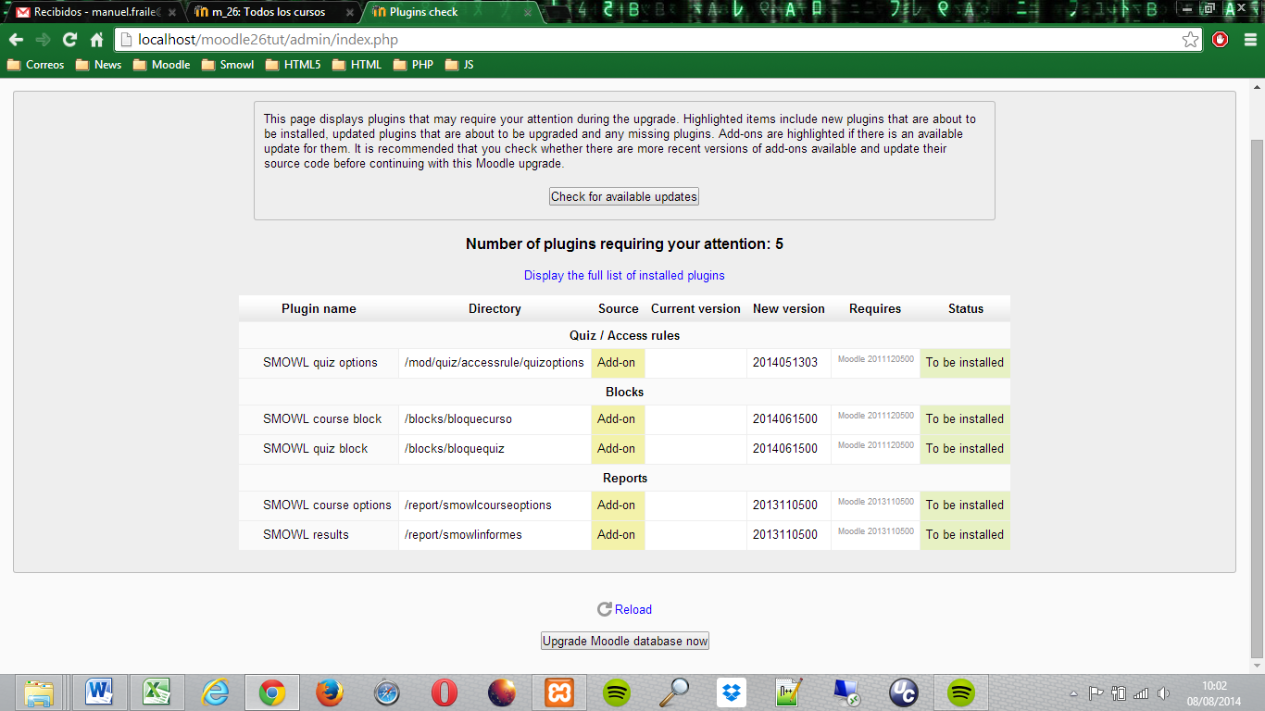

1. Finally, a new window indicating that the installation was successful will appear. To conclude, we must **press *"Continue"* button** to return to the homepage of Moodle.

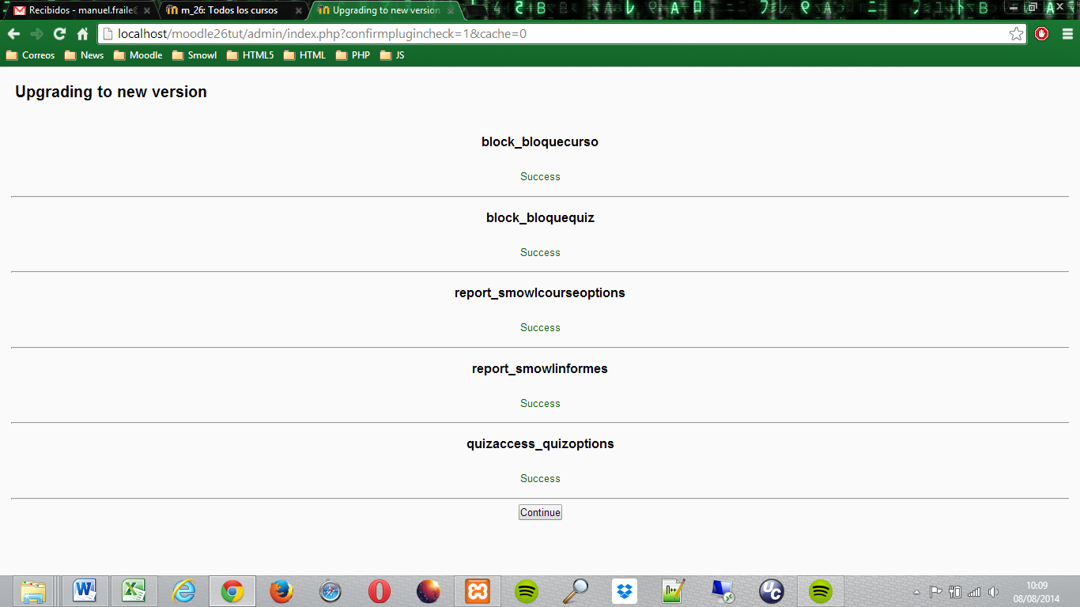

1. Configuring SMOWL in a course

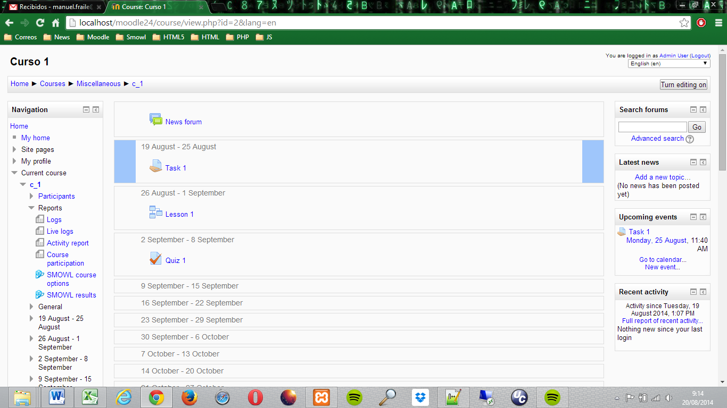In this section we will walk you through the configuration of SMOWL’s facial recognition software in a course.

1. To access course’s settings, we must click on ***"SMOWL course options"*** option found within the current course menu, inside *"Reports"* section, that is in *“Navigation”* block.
2. Within the *SMOWL options menu* we find a number of settings that must be set:
   1. 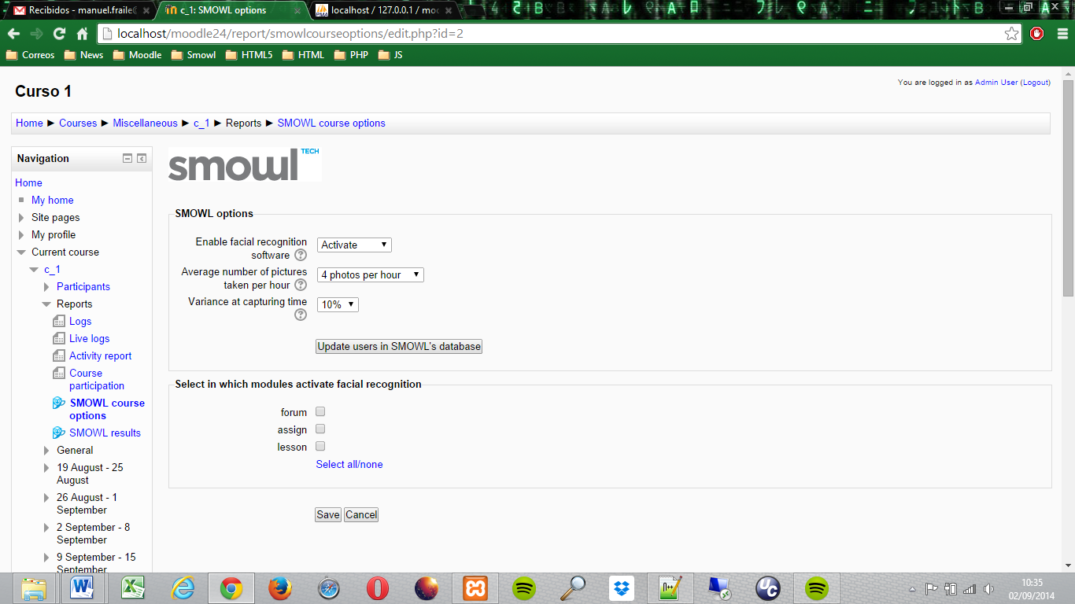Firstly, we must choose whether to **activate** or **not activate** the face recognition software.
   2. After enabling facial recognition, the **average number of photos** per hour that will be captured must be selected.
   3. Next, we must select the **variation** of the photo capture interval.
   4. Finally, we must tick the **modules** of the course **where** we want to **activate the software**, apart from the course’s homepage.
   5. To end up, we must click the ***“Save”*** button to store selected settings.
   6. If **new users** are **enrolled** in the course, we will have to press ***"Update users in SMOWL’s database"* button** in order to update the list of enrolled users in SMOWL’s database.
3. If we want to **update** any parameter of the **course’s configuration**, we must access to the *SMOWL options menu* and **repeat** the **second step.**
4. Configuring SMOWL in a quiz

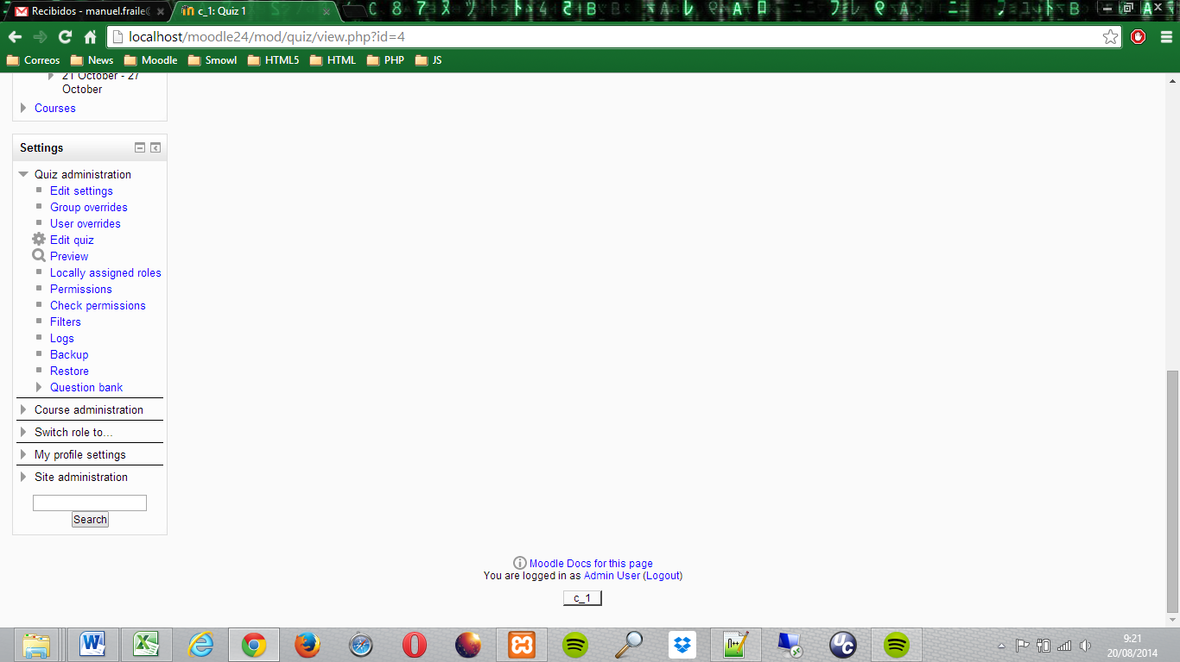The third part of this handbook will guide you through the configuration of SMOWL’s facial recognition software in a quiz.

1. In order to be able to configure SMOWL’s facial recognition software in a quiz, we must access to edit its settings. For this, we must click the ***“Edit settings”*** option within the *Quiz administration* menu inside the *“Settings”* block.
2. 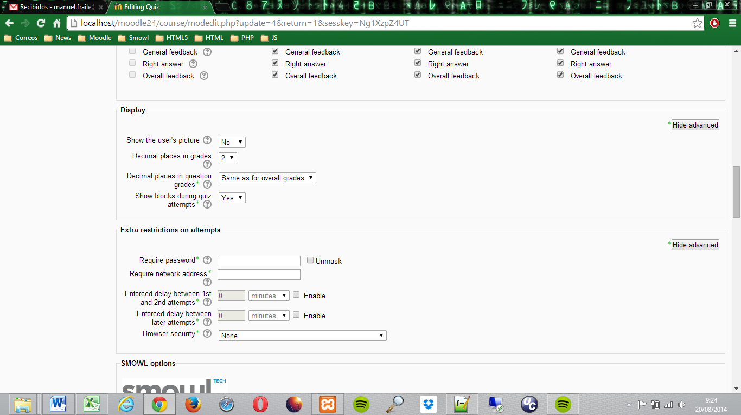Once we are inside the settings of the quiz, the first step is to activate the visualization of blocks during quiz attempts. For this, within *“Display”* section and after clicking *“Show advanced”* button, we must change to ***“YES”*** the option ***“Show blocks during quiz attempts”***.
3. 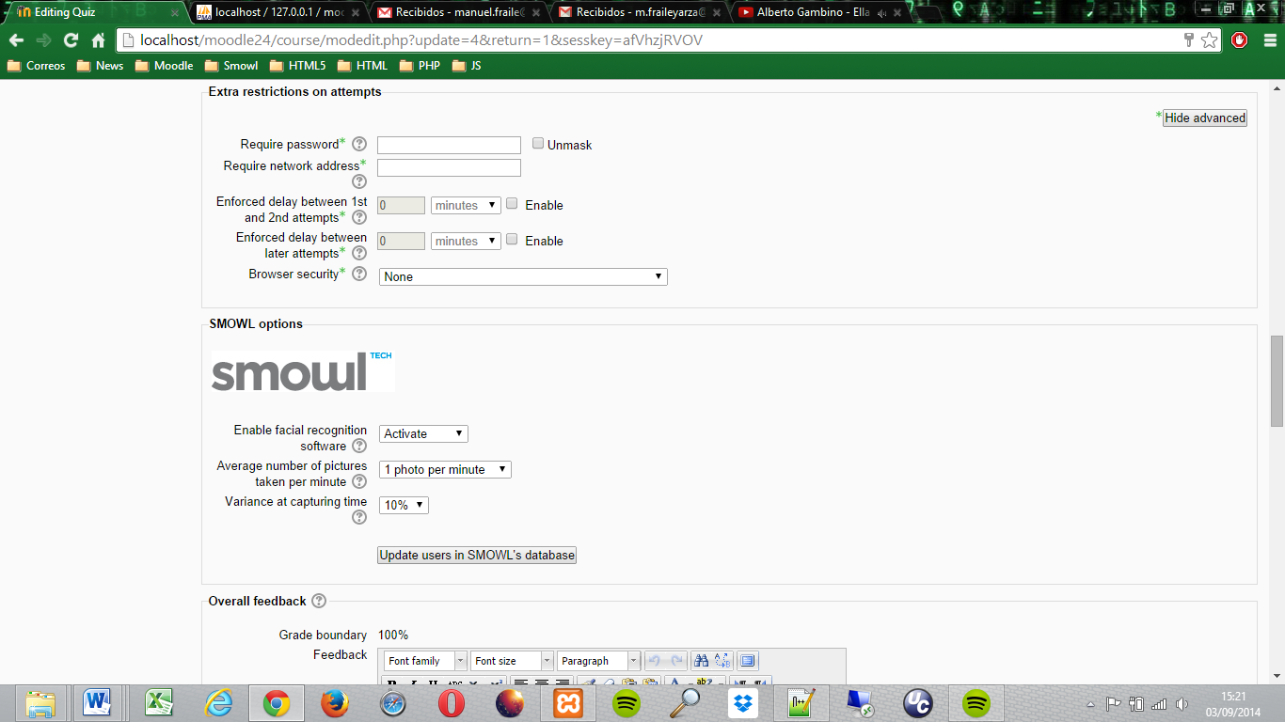Next, we must access to *“SMOWL options”* section inside quiz settings to configure facial recognition:
   1. Firstly, whether **activate** facial recognition software or **not activate** it must be selected.
   2. Then, we must choose the **average number of pictures taken per minute**.
   3. Finally, the **variance at capturing time** must be selected.
   4. If **new users** are **enrolled** in the course so they are able to take the quiz, we will have to press ***"Update users in SMOWL’s database"* button** in order to update the list of enrolled users in SMOWL’s database.
4. To end up the quiz configuration, we must press one of the buttons which are at the bottom of the settings. Those settings are ***“Save and return to course”*** or ***“Save and display”***, depending on where we want to go after saving data.
5. If we want to **modify** any parameter of **facial recognition software** within a quiz, we must access to the settings of the quiz and **repeat** the **third step.**
6. Display results

The last section of the guide aims to explain how to visualize the data and results from the application of SMOWL’s face recognition software in a course or quiz.

1. If we want to access to results display page, we must click the **“*SMOWL results”*** option which is inside *“Reports”* section within the *“Course administration”* menu inside *“Administration”* block.

Once we have accessed to the results display page, we will distinguish between viewing the results of a course or a quiz.

1. Starting with the **COURSE**, we must configure 3 different search criteria:
   1. 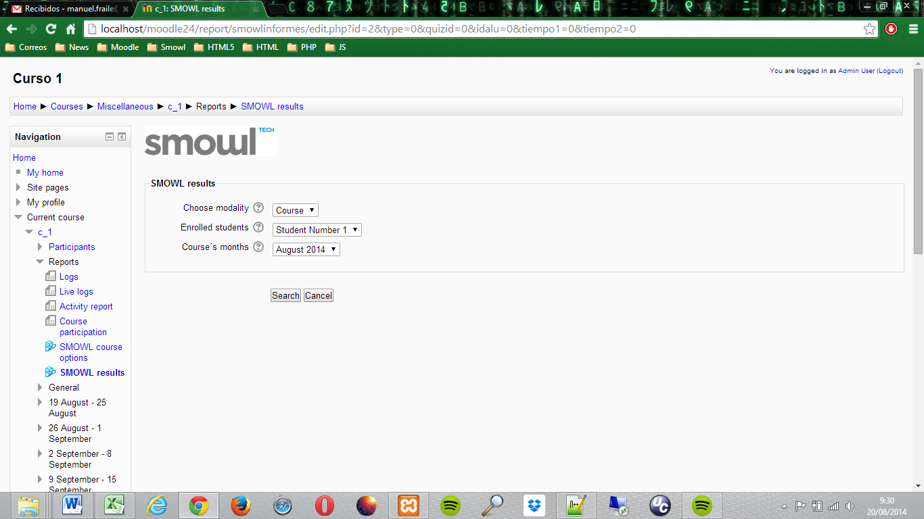Firstly, in the ***“Choose modality”*** section, the option ***“Course”*** must be selected.
   2. Then, we must choose the student whose data we want to be shown in the ***“Enrolled students”*** option.
   3. Lastly, we must select which of the ***Course’s months*** data must be displayed.
   4. To end up, we must press the ***“Search”*** button in order to load the results of SMOWL’s facial recognition software.
2. On the other hand, to visualize the results of facial recognition within a **QUIZ**, 4 different search criteria must be selected:
   1. 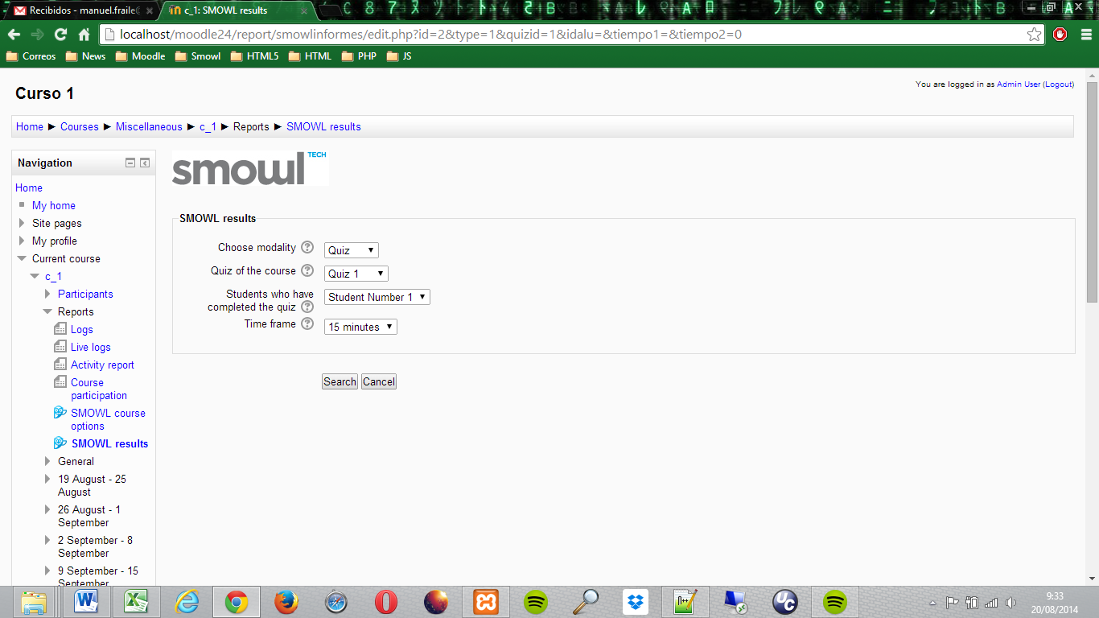The first step is to check if the ***“Quiz”*** option is selected in the ***“Choose modality”*** search criteria.
   2. Next, we must select the quiz whose data we want to display in the ***“Quiz of the course”*** option.

After the previous step, the next options will be loaded with the students that have completed the quiz and the time frame.

* 1. The third step is to select the **student** whose data we want to view from the section ***“Students who have completed the quiz”***.
  2. Finally, the ***“Time frame”*** by which the displayed results will be grouped must be selected.
  3. To end up all the process and view the results, we must press the ***“Search”*** button.

